Running VB Forum 2000

Step 1: Running the Application
Open the application. It should look like the image below.
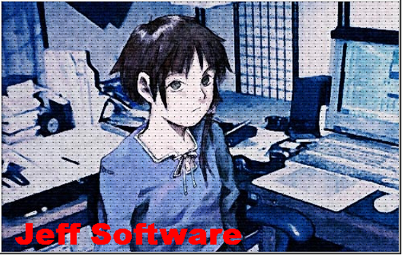
Image 1: The splash screen.

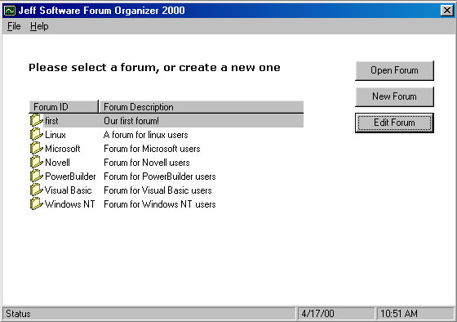
Image 2: The Main Application
Step 2: Adding a New Forum
To add a New Forum you must do the following.

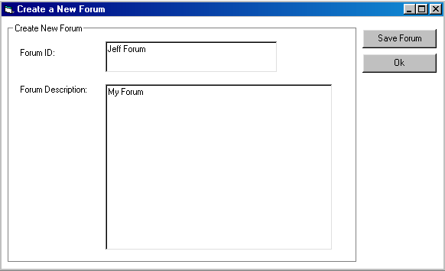
Image 3: Creating a New Forum

Then click on save. That will save the new forum to the database and will go back to the main forum.

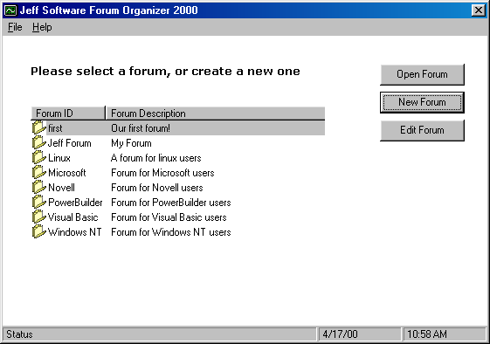
Image 4: New forum is now added.

Step 3: Creating a New Message.

Double click on the forum that you want to create a message.

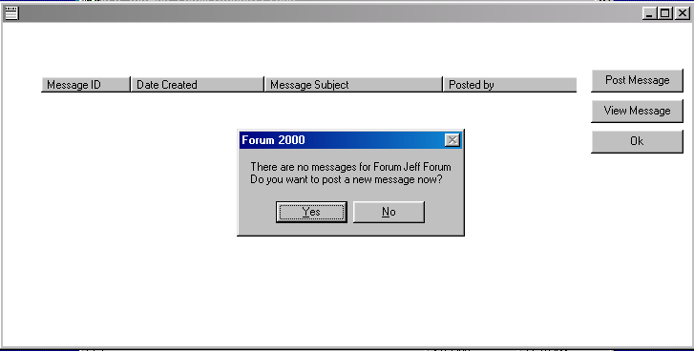
Image 5: Prompt message.

If no messages are posted then the program will prompt you if you want to create a new message.

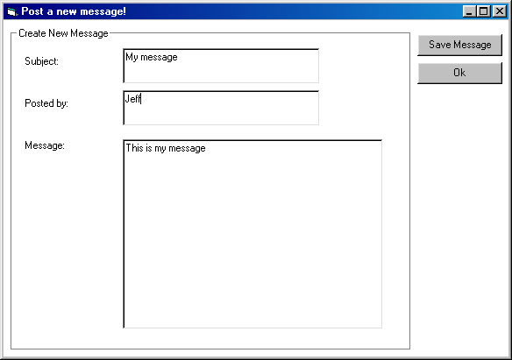
Image 6: New Message.

Type in the Subject, Posted By, and Message then click Save Message.

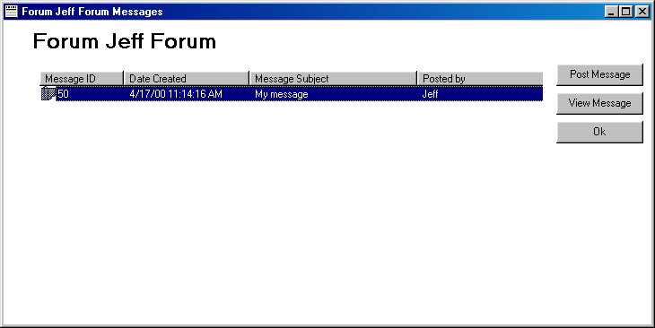
Image 7: Messages for Forum Jeff

Step 4: Posting a New Message, Viewing Messages, and Deleting Messages
To post a New Message you need to do the following.

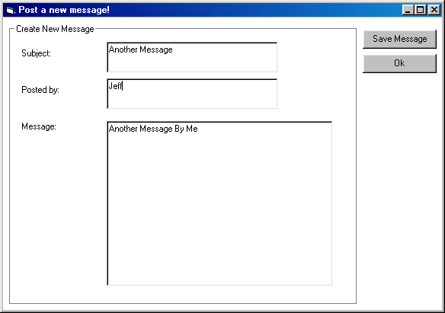
Image 6: Another Message

Click on Save Message when you’re done.

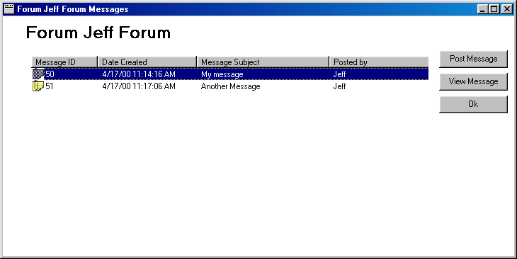
Image 7: The updated forum messages
To view a message you must select the message and click View Message.

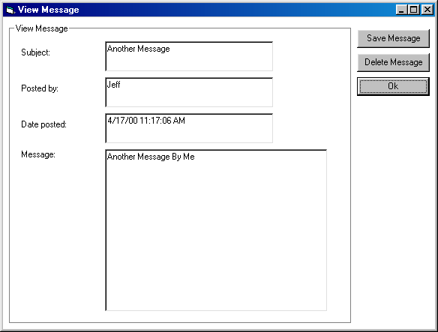
Image 8: The view message window.

Click Ok to go back to the messages.

To delete a Message you must view the message and click Delete Message.

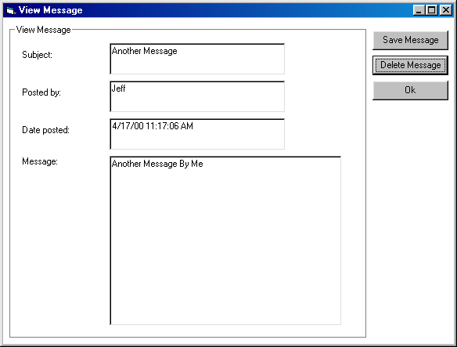
Image 9: The delete message window.

Click Delete Message and that will bring you to the messages window again

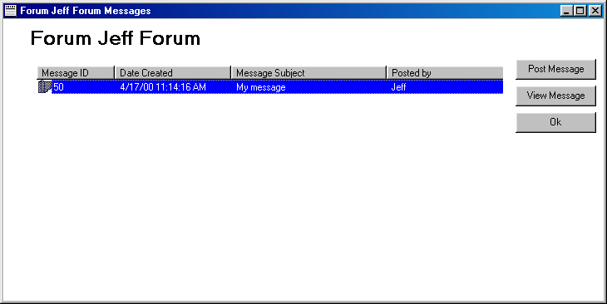
Image 10: The updated messages window

Now go back to the Forum window by clicking Ok.

Step 5: Editing, and Deleting a Forum
To edit a Forum you must click the forum you want to edit and click the Edit Forum.

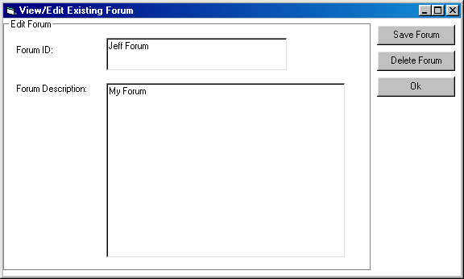
Image 11: The View/Edit Forum.

To delete a Forum you must click on Delete Forum

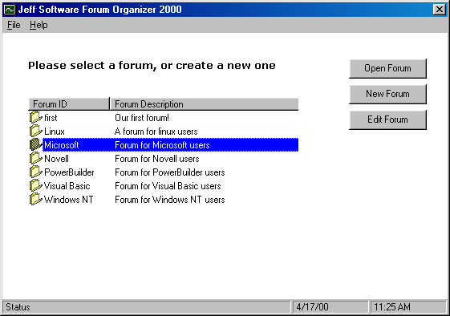
Image 12: The updated Forums Window

Lastly to exit the program click on File and then Exit

